Fun Fold Confetti Card
YouTube Video Link https://youtu.be/e_x4AJd2faQ

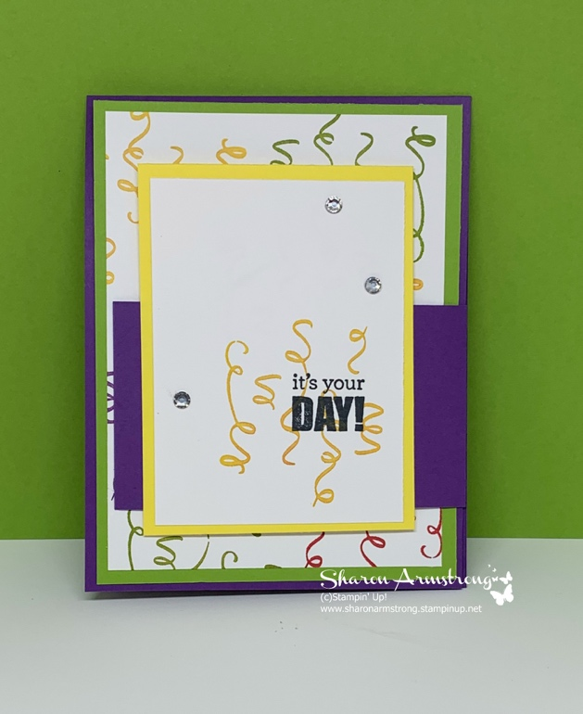

Measurements
Gorgeous Grape Card Stock - 4 1/4" x 11", scored and folded at 5 1/2"
Gorgeous Grape Card Stock - 2" x 6", scored at 2"
Highland Heather or Granny Apple Green Card Stock Layer - 4" x 5 1/4"
Highland Heather or Pineapple Punch layer - 3" x 4"
Whisper White Card Stock - 3 3/4" x 5", 2 3/4" x 3 3/4"
Whisper White Card Stock for inside - 4" x 5 1/4'
Product List
- Birthday Backgrounds Cling-Mount Stamp Set [151260] $18.00
- Itty Bitty Birthdays Cling Stamp Set [148618] $23.00
- Gorgeous Grape 8-1/2" X 11" Cardstock [146987] $8.75
- Gorgeous Grape Classic Stampin' Pad [147099] $7.50
- Pineapple Punch 8-1/2" X 11" Cardstock [146971] $8.75
- Pineapple Punch Classic Stampin' Pad [147141] $7.50
- Granny Apple Green 8-1/2" X 11" Cardstock [146990] $8.75
- Granny Apple Green Stampin' Pad [147095] $7.50
- Highland Heather 8-1/2" X 11" Cardstock [146986] $8.75
- Highland Heather Classic Stampin' Pad [147103] $7.50
- Real Red Classic Stampin' Pad [147084] $7.50
- Whisper White 8-1/2" X 11" Cardstock [100730] $9.75
- Rhinestone Basic Jewels [144220] $5.00
- Pearl Basic Jewels [144219] $5.00

